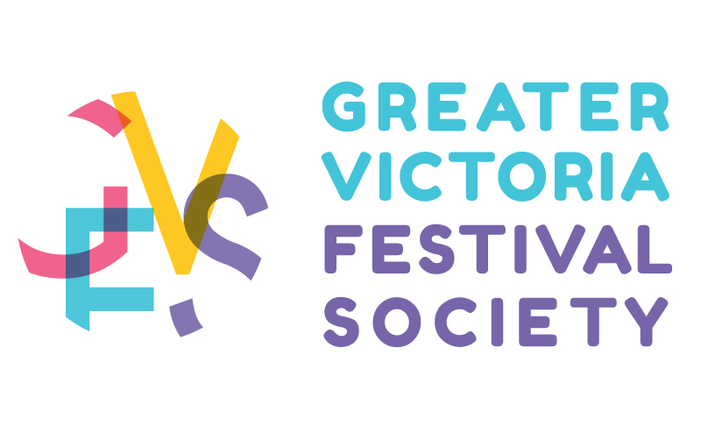
THRIFTY FOODS 124th VICTORIA DAY PARADE
Presented by Chek TV
ENTRY FORM

PARADE DATE: May 20, 2024 APPLICATION CLOSING DATE: April 10, 2024

Name of Entry:
Contact Person: phone:
Mailing Address: postal code:
Email Address: Approx. number of persons in Unit: ______
Will you have music on your entry? Yes ______ No _______ Approximate Length of Entry______________

Category of Judging for Your Entry - Please Check Appropriate Box: You will only be judged in the category you check off below

CARS - DECORATED CANADIAN BANDS - SCHOOL
CARS - ANTIQUE DANCING GROUP
CARS – RACING PERFORMING ACTS - DOGS, BICYCLES, CLOWNS
NON PROFIT ENTRY - FLOATS MISCELLANEOUS/WALKING
COMMERCIAL /BUSINESS ENTRY - FLOATS GROUPS

Entry Fee Must Accompany Your Application: Please make payable to Greater Victoria Festival Society
ONLY COMPLETED APPLICATIONS WITH PAYMENT, AND INSURANCE WILL BE CONSIDERED

Non-profit Organization $75.00 Commercial $395.00

Please provide MEDIA commentary in 50 words or less: (Describe your entry or business) _______________________________________________________________________________________________________________________________________________________________________________________________________________________________________________________________________________________

INSURANCE REQUIREMENTS

All entries must carry a minimum $2,000,000 general liability insurance that covers the time period of the Parade **Coverage must include additional named insured The Greater Victoria Festival Society, City of Victoria- 1 Centennial Square Victoria BC V8W 1P6, Thrifty Foods/Sobeys – 3030 Merchant Way, #106, Langford BC V9B 0X1 and Central Walk Mayfair Shopping Mall – 3147 Douglas Street Victoria BC V8Z 6E3. Any entry without proof of insurance will not be allowed to participate in the Parade. Proof of insurance must be provided to the Greater Victoria Festival Society no later than April 10, 2024. NO EXCEPTIONS

WAIVER

On behalf of the firm/organization/individual above and all participants in the entry, I the undersigned agree that neither the Greater Victoria Festival Society, and the City of Victoria nor any agent, employee or volunteer of any of the 2 assumes any responsibility for any personal injury or property damage suffered in connection with the Parade howsoever caused (including negligence and excepting only willful misconduct) and agree to release and hold harmless such parties from any claims for such injury or damage.

Signature Please print full name Date

Payment can be made by E-transfer to gvfsvic@gmail.com, Paypal or please make cheque payable to the Greater Victoria Festival Society, and mail application form, a copy of the insurance, payment and a Picture or Design of your entry to:

Greater Victoria Festival Society
#602-620 View Street
Victoria BC V8W 1J6

Entries may be emailed with a copy of insurance to gvfsvic@gmail.com

Any questions please call Kelly Kurta, Executive Director at 250-382-3111

WE ARE SO EXCITED AND LOOKING FORWARD TO WELCOMING YOU TO OUR 124th PARADE !!

