THRIFTY FOODS 124TH VICTORIA DAY PARADE
Presented by Chek TV

ENTRY FORM

U.S.A. and CANADIAN BAND & DRILL TEAM CATEGORIES - APPLICATION FORM
PARADE DATE: May 20, 2024 DEADLINE: April 15, 2024

ENTRY FREE WAIVED FOR PARADE .

Name of School:
Name of Marching Group:
Number of students in entire unit ____________________________________
Do you want to be considered for competition? yes no
School Enrollment grades 10-12 Size of Band (incl all drill/marching)__________ _____
Band Director Name: Home Phone:
Drill Team Director: School Phone:
Email: Fax:
Mailing Address:
City & State: Zip Code:

INFORMATION FOR PRESS AND MEDIA (50 words or less please) Please send picture FOR MEDIA
Drum Major/Majorette: Drill Captain:

Additional info for TV commentary (prizes won, honors received, events, etc): (or attach write up)

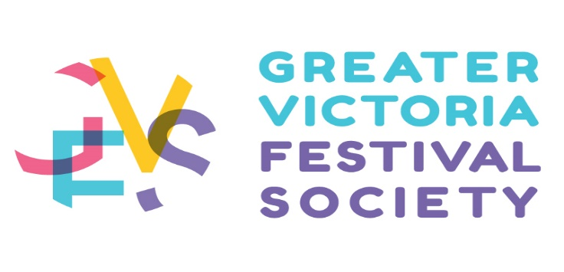

Number of year’s participation in the Victoria Day Parade by this school:

Which Hotel are you staying at in Victoria BC? ________________ How many rooms____________
How many nights? ____________

Would you like to perform in the Performances at the Lawns of the Legislature on Saturday May 18 or Sunday May 19? If yes, please indicate which date and times (please note these are first come first served)
_________________________________________________________________________________________________________________________________________________________________________________

IMPORTANT

INSURANCE REQUIREMENTS
All entries must carry a minimum $2,000,000 general liability insurance that covers the time period of the Parade **Coverage must include The Greater Victoria Festival Society, City of Victoria, 1 Centennial Square Victoria BC V8 and Thrifty Foods / Sobeys, as “additional insured” on the policy**.

WAIVER
On behalf of the firm/organization/individual above and all participants in the entry, I the undersigned agree that neither the Greater Victoria Festival Society and the City of Victoria nor any agent, employee or volunteer of any of the 2 assumes any responsibility for any personal injury or property damage suffered in connection with the Parade howsoever caused (including negligence and excepting only willful misconduct) and agree to release and hold harmless such parties from any claims for such injury or damage.

Signature Please print full name Date

Return this form by mail or email with:
- Proof of insurance for the group as outlined in the application letter;
- Waiver signed by appropriate school personnel;

To: Kelly Kurta, Executive Director and Parade Chairman
Greater Victoria Festival Society
602 - 620 View Street, Victoria, BC V8W 1J6 Tel: 250-382-3111 gvfsvic@gmail.com

